Microsoft Teams End-user Guide
- Microsoft Teams has been made available to download via Software Center.
  - From your start menu browse Software Center
  - Available Software Microsoft Teams (check item click install selected)

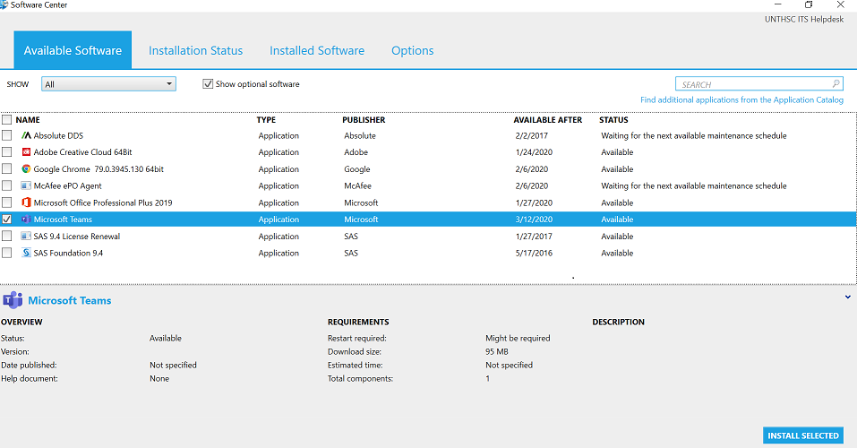

- Sign in to Microsoft Teams using your University issued email:
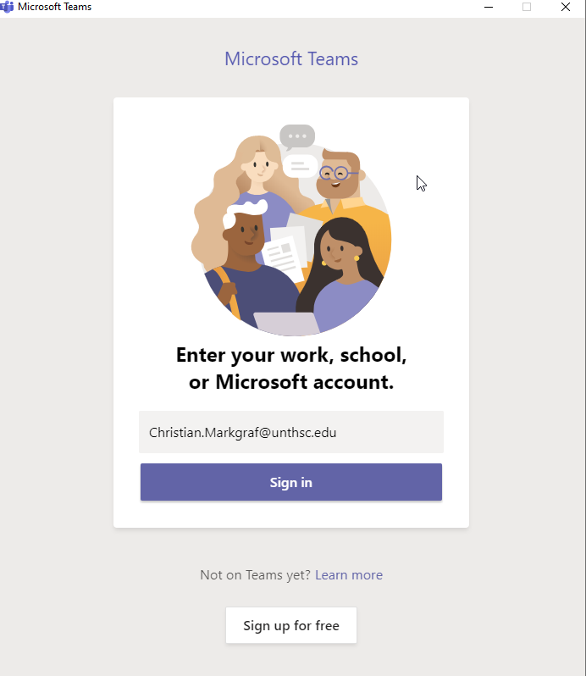

- Take an interactive Training Tour:

Interactive Tour

Join a Meeting

Collaborative workspace for
- Team Files
- Meetings
- Collaborative Conversation
- Office 365 application integration

Connect from anywhere  The Microsoft Teams desktop enable teamwork from anywhere. | Customize channels  Upload files to the appropriate channel  and pin frequently used files | Add apps to channels.  Frequent used app integration—such as Word, PowerPoint, Excel, PowerBI, ect.
Collaboration  Create team collaboration work spaces with dedicated channels to specific topics, projects,  disciplines ect. | Elevate email conversations.  Forward email to a team channel to continue the discussion in a threaded  chat conversation, with attachments automatically uploaded for easy team  co-authoring. | Initiate Chat  Create individual or small group chats with colleagues you work with routinely.

Get Started with Microsoft Teams

